**Electronic supplement**

**Photographs of study sites**

*All photos taken by A.H. Baldwin*

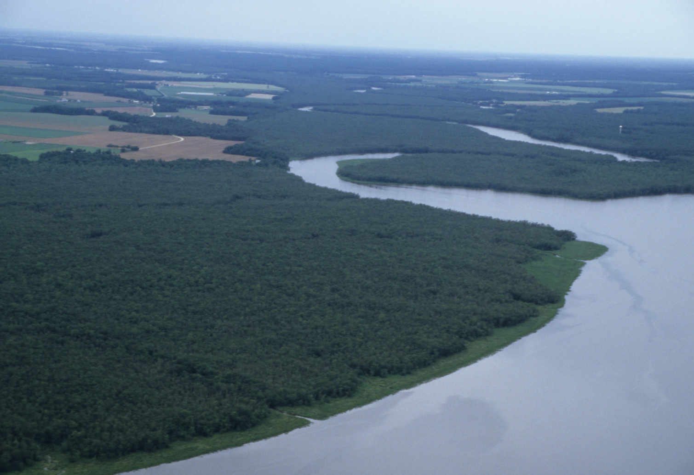

Photo 1. Aerial view looking northward. The large water body to the right foreground is the Nanticoke main stem, and the tributary flowing in from the left is Marshyhope Creek. Tidal fresh-oligohaline swamps are the large forest in the left foreground with a fringe of marshes visible along the Nanticoke main stem.

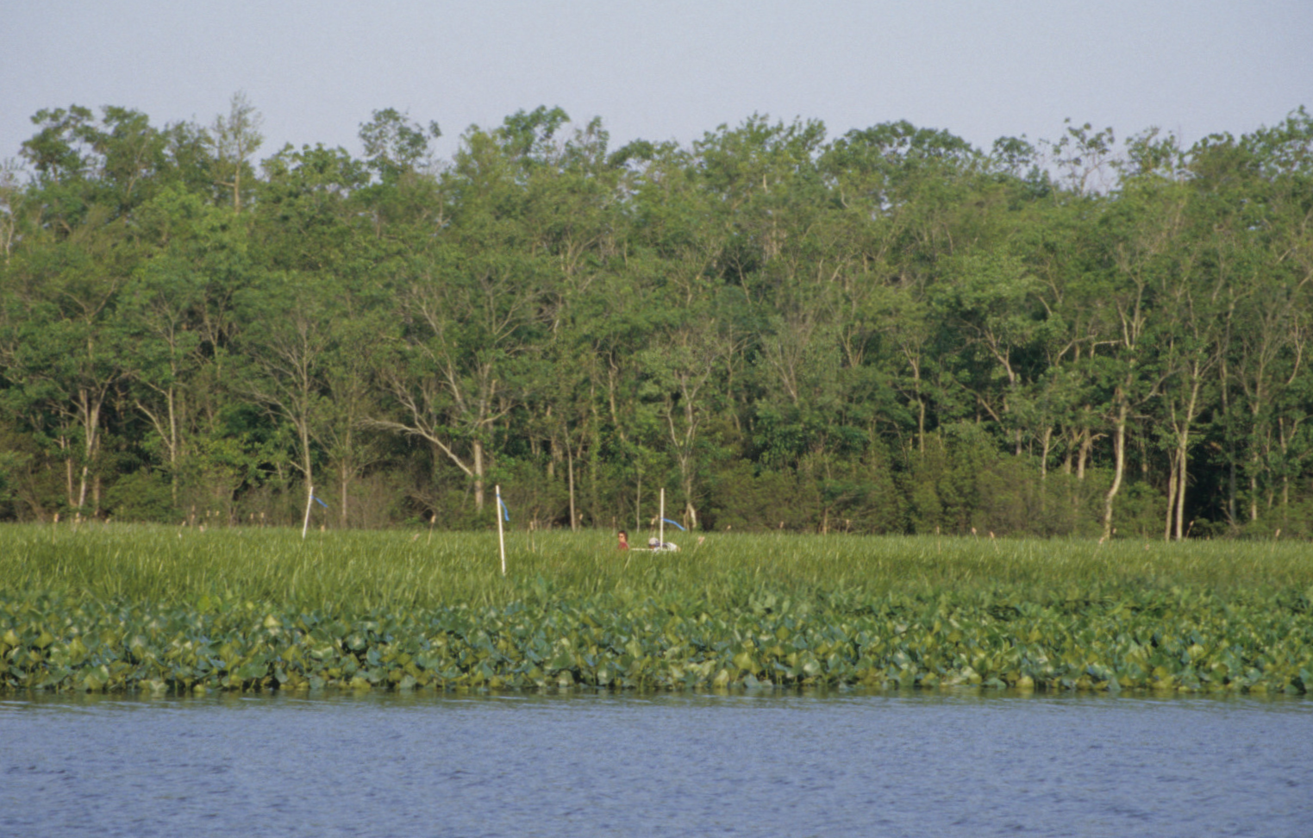

Photo 2. Ground view of tidal freshwater marsh in the foreground with tidal swamp in the background. PVC plot marker poles and an ecologist are visible in the marsh.

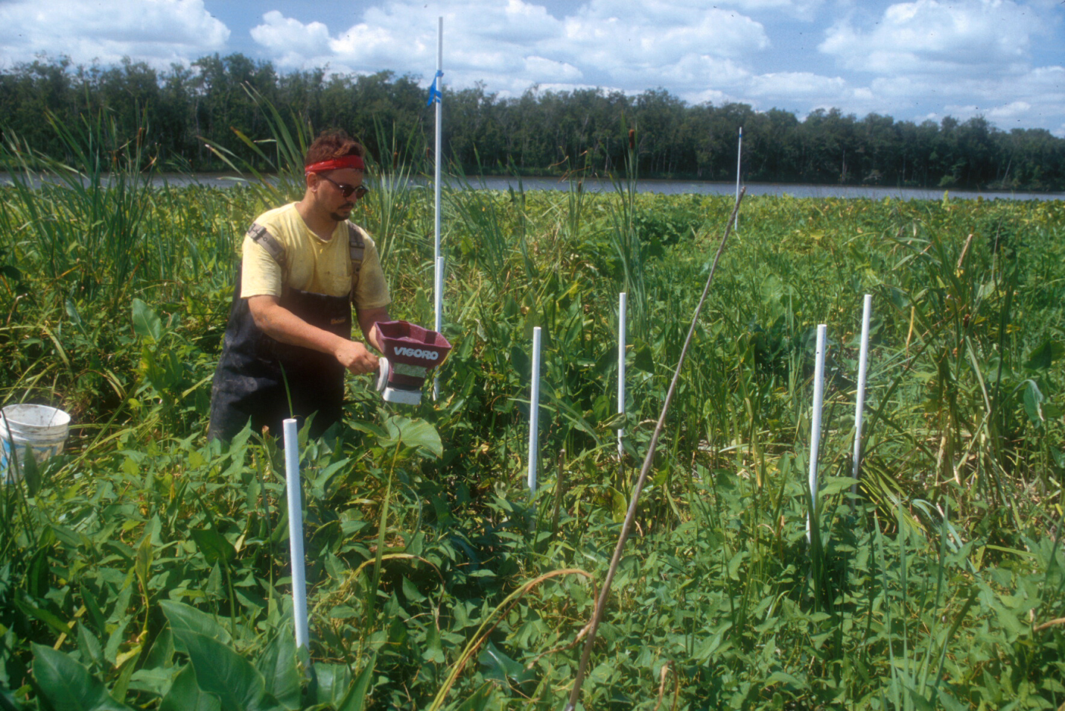

Photo 3. Broadcasting of pelletized fertilizer onto 2x2-m herbaceous vegetation plots in a Nanticoke tidal freshwater marsh. The short PVC poles are the supports for a 1x2-m quadrat placed over the plots for non-destructive monitoring.

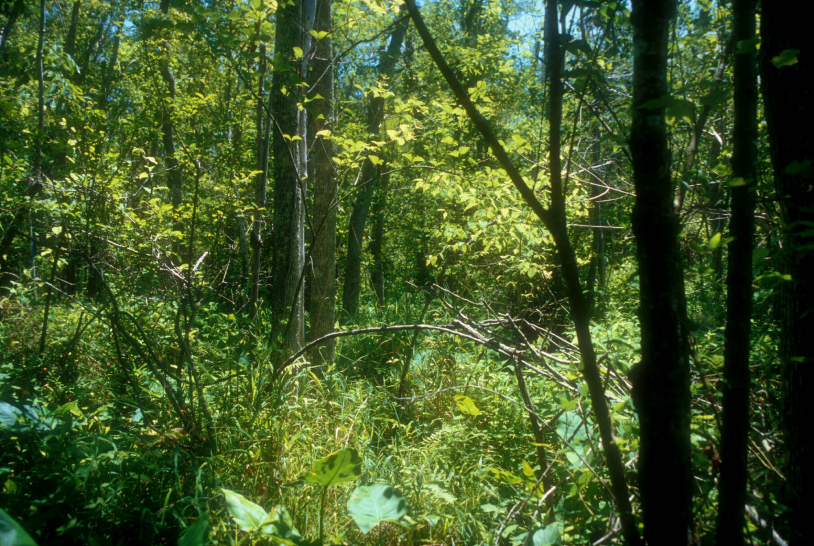

Photo 4. Diverse herbaceous understory of a tidal freshwater swamp at the confluence of Marshyhope Creek and the main stem of the Nanticoke River.

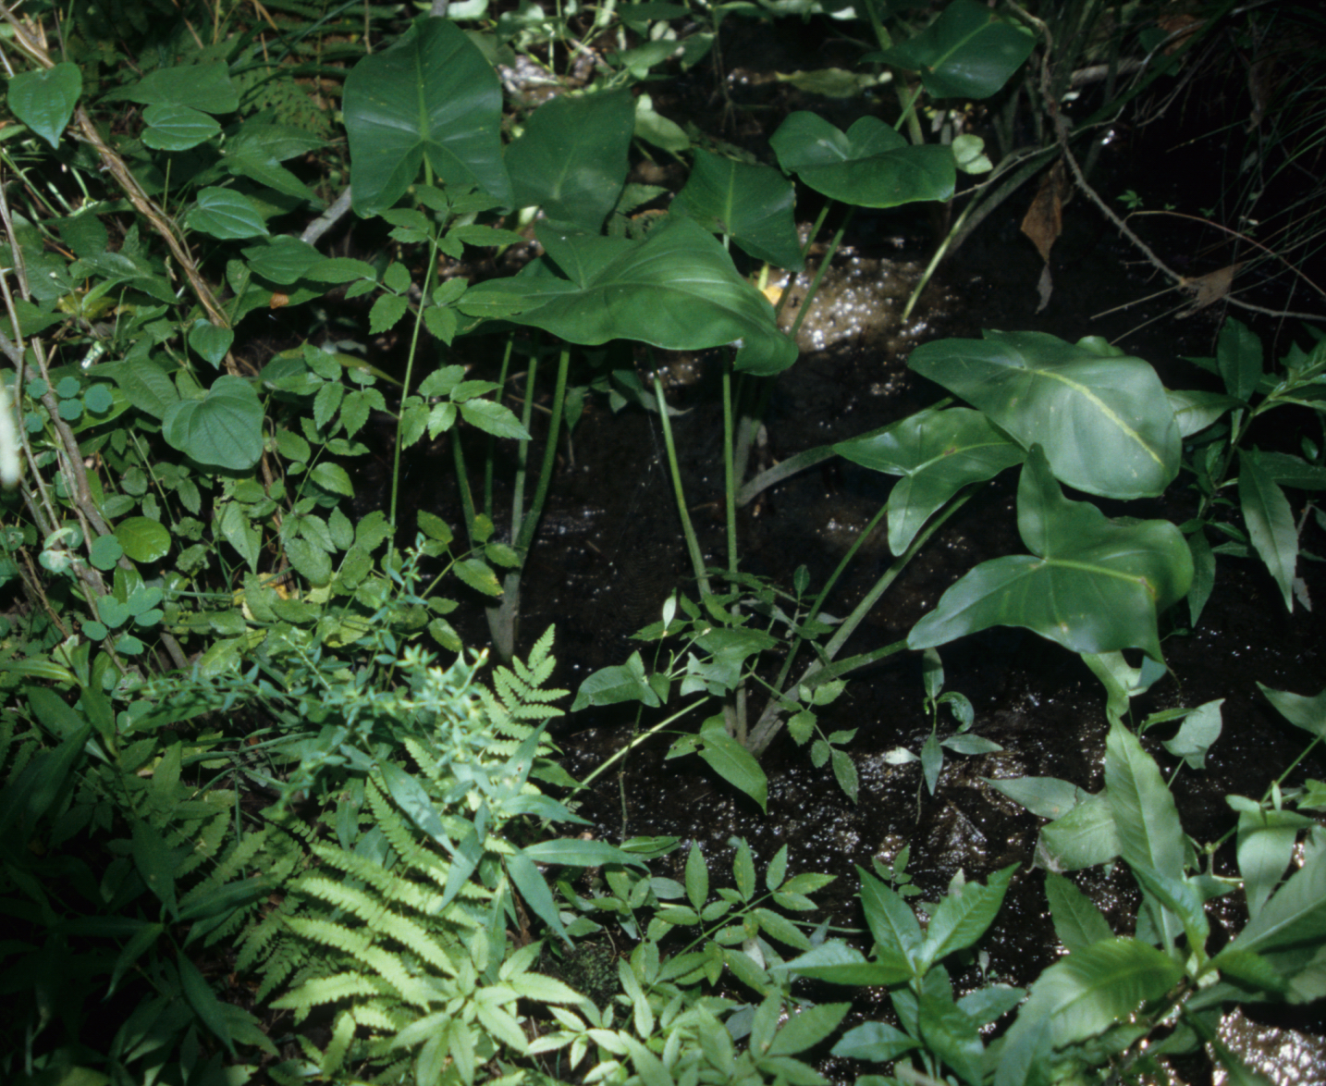

Photo 5. Swamp herbaceous understory vegetation. A small hummock occupies the lower left of the frame (with ferns and other herbs) and a hollow occupies the rest of the frame (with dark soil and arrow-shaped *Peltandra virginica* leaves).

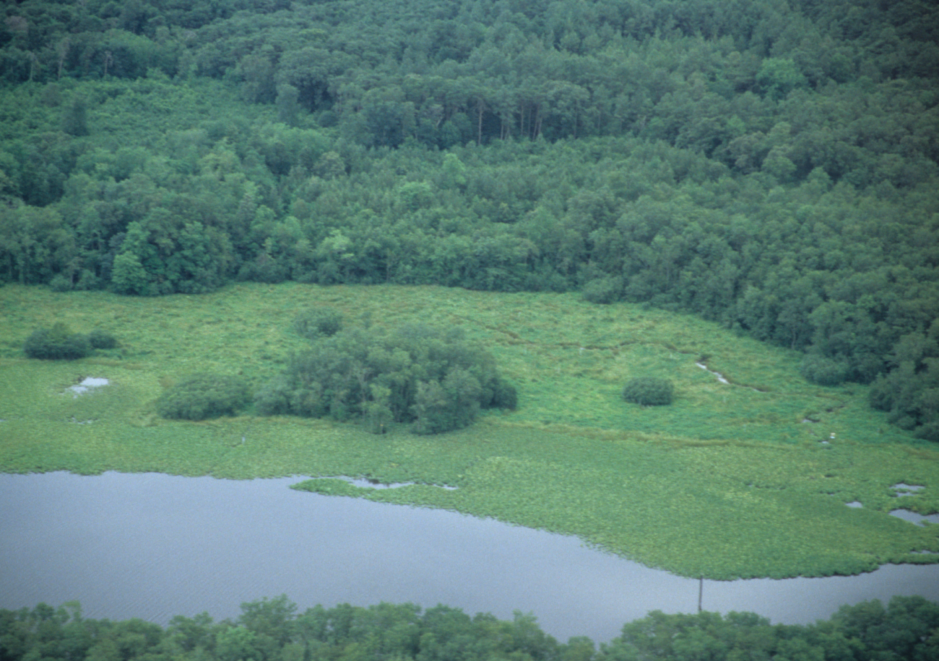

Photo 6. Aerial view of the Broad Creek experimental marsh site. The location of fertilization plots is in the band of “high marsh” vegetation the stretches horizontally across the middle of the frame between the swamp forest at the top of the frame the different-textured “low marsh”. Broad Creek is visible below the low marsh, and the Broad Creek swamp experimental plots are located in the forest at the bottom of the frame.